MINUTES OF THE STUDENT ANNUAL GENERAL MEETING HELD OUTSIDE ON THE UNION COURTYARD, CUMBERLAND STREET ON THURSDAY 23 OCTOBER 2025 AT 12.52PM

PRESENT
Jack Evans (Chair) and over 120 OUSA members
IN ATTENDANCE
Donna Jones (Minute Secretary), Debbie Downs (Chief Executive Officer), Mukesh Kumar (OUSA Financial Controller) and other OUSA staff
APOLOGIES
There were no apologies to record
MINUTES OF THE PREVIOUS EXECUTIVE MEETING
Joshua Stewart/Stella Lynch
01/25 THAT the minutes of the Student Annual General Meeting held on 17 October 2024 be accepted as a true and accurate record.
CARRIED
MATTERS ARISING FROM THOSE MINUTES
No matters were forth coming.
REPORTING AND VALIDATING A CONSTITUTIONAL BREACH
Liam White/Stella Lynch
02/25 THAT OUSA reports to the Student Body a breach of the Constitution to allow the Association to hold an AGM outside of formal classes to ensure the Association’s Budget for 2026 be approved and the Constitution be amended in compliance with the 2022 Incorporated Societies Act.
CARRIED
Liam White/Stella Lynch
03/25 THAT the Student Body resolves by way of Special resolution to validate the breach above of the Constitution and Rules as reported to it by the Officers of the Association, because it satisfied that:
- There has been substantial compliance
- The breach has not materially affected, and will not foreseeably materially affect, the rights or interests of any person or affiliated body; and
- The breach resulted in a positive benefit to the OUSA and its members and the objects of the Association.
CARRIED
(special resolution)

OUSA BUDGET 2026
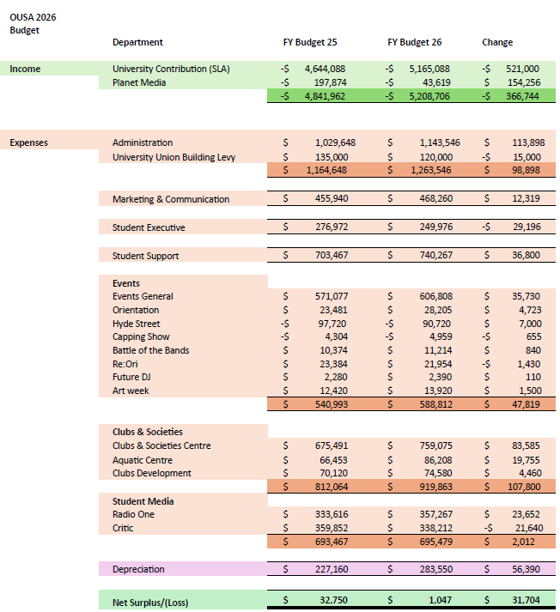
There were three questions from a life member:
- Why has Planet Media’s budgeted income dropped by so much?
Over the past few years, the media sales environment has been poor. Our traditional media sales haven’t been attractive to businesses and has led to Planet Media performing poorly compared to budget over the past few years. This budget for 2026 is realistic.

- Congratulations on the increase of funding from the SLA. What is the per student amount that this represents?

- The increase that OUSA got was significant, but we got a much larger increase than the University run student services. The percentage increase that was agreed to is still confidential as it needs to be approved by university council, but the overall percentage increase to the student services fee is far lower than the increase OUSA is receiving.

- Why is there no income from the commercial arm of Ousa recorded as income?
OUSA’s commercial entities have their budgeting at different times of the year to OUSA the OUSA Proper (the part directly overseen by the Executive). Because of this, we don’t have these budgets approved by the student body.
Another life member asked for the Chair to ask the following questions:
- Between 31 December 2019 and 31 December 2022, OUSA salaries grew by a total of about $100k. Between 31 December 2022 and 31 December 2024 they grew by $900k. This is at a time when the NZUSA support remained flat or was cut, and executive funding has been near stagnant or cut. Why is there no cost control on salaries? How does this support OUSA to deliver to students?
These significant increases have been due to high inflation over the past three years.

- Why is it only the Critic and the student executive receiving funding cuts? These are the most student facing areas that are crucial to OUSAs function. Why aren't they coming from other areas, such as marketing?
Critic and the Exec aren’t having their budgets cut, rather the changes being made are to better support these departments to provide for students.

Daniel Leamy/Amy Martin
04/25 THAT the OUSA budget for 2026 be set in its entirety.
CARRIED
APPOINTMENT OF AUDITORS FOR 2026
Audit Professionals have been the OUSA Auditors to date and have been very good.

Amy Martin/Daniel Leamy
05/25 THAT Audit Professionals be appointed the OUSA Auditors for 2026.
CARRIED
CONSTITUTIONAL CHANGES AND ADDITIONS FOR 2022 CHARITIES ACT COMPLIANCE AND RE-REGISTRATION
Amy Martin (Administrative Vice President) addressed the meeting explaining the changes for OUSA constitution to get re-registered under the Incorporated Societies Act 2022 approved by the student body.
The proposed changes were put up for 10 days’ notice as required after being to the OUSA Lawyers. A summary was written up to make the changes easier to understand.
Kyle Matthews, life member, presented a statement for the Chair to read to the meeting pertaining to clause 13 Prerequisites to being an Executive Officer
OUSA used to have a clause which forced the President to be a student in the constitution many years ago because it was the only way they could be a member while serving their term. In 1994 the President had to rush out quickly on the last day of enrolments and enrol in a paper to fulfil the constitutional requirements. I don't think he ever attended the class.
When we rewrote the constitution in the early 2000s, we amended the constitution so that the President was automatically a special member during their term to prevent this because it was nonsense. The Presidency is a full-time job; there's no need for them to be a student.
It seems OUSA is forcing the President to be a student again and I can't see what purpose that serves, other than forcing them to enrol in a course, pay the university's horrendous fees, and all to meet the constitutional requirements.
Molly Smith-Soppet/Will Biss
06/25 THAT OUSA Incorporated re-register under the Incorporated Societies Act 2022.
Daniel Stride Against
CARRIED
Amy Martin/Daniel Leamy
07/25 THAT the amendments and additions to the OUSA Incorporated constitution be accepted and approved.
Daniel Stride Against
CARRIED
GENERAL BUSINESS
To incentivise attendance OUSA held prize draws, and these were gladly received.
The students were thanked for attending followed by a closing Karakia.

Meeting closed 1.18pm

Signed: ___________________________________ Date: _________

